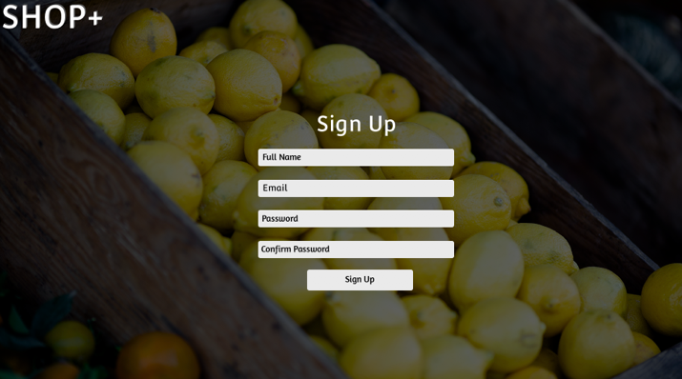**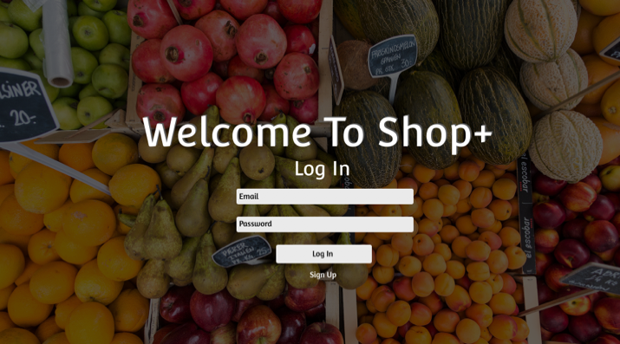Design Concept Documentation for SHOP+**

**Log In & Sign Up:** Using Illustrator to create the wireframes, I took them and created the design in Photoshop. As the designer, I chose to make the design simple yet professional and I succeed this look by having a simple layout that a user would be able to function with. Also, the background is connected to shopping by having a market stall of fruit and veg, with advice from other group members this was the best look for the design over the choice of an image, gradient fill or a solid color. The user would need easy navigation so everything is straight forward on the first page and the second page which helps a user sign in or create an account. I chose to have different backgrounds on these two pages so the user would know they are on a different page. With the ‘Login’ and ‘Sign up’ page I wanted them to have a similar look with the white form boxes and the white font because it keeps the app consistent and sticks within the theme I was trying to achieve. This also makes it stand out from the blackened background as it contrasts and makes it clear for a user. However, if I were to do this design again I would look at changing the font and making it more formal to give it a smarter look.

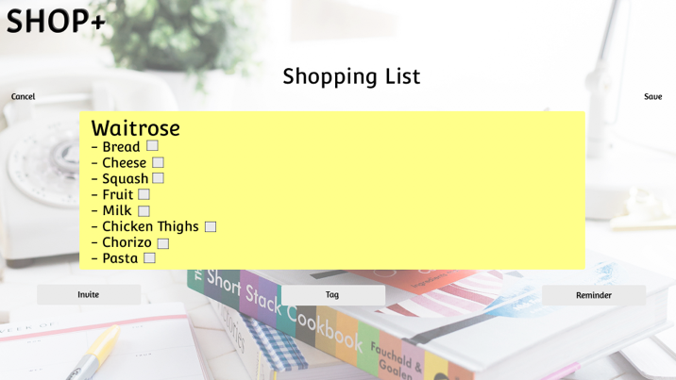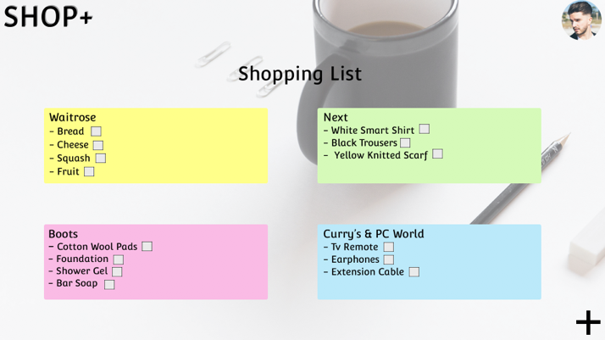

**Shopping List:** These are the main pages that a user would be using throughout the app I wanted to make the page look appealing and have a clear navigation for the user to find their shopping lists and create their shopping lists. With inspiration from the “Google Keep” app I wanted to make the app easy for users to color label their lists. This would be done through a “Tag” button on the creating a shopping list page. The navigation that would be used to help the user on these pages are buttons.

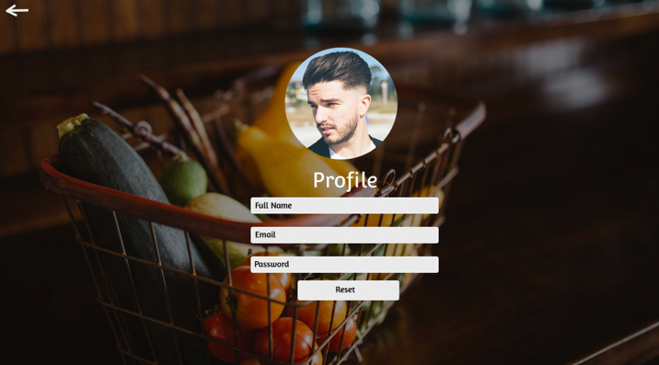

**Profile:** The profile page has a similar look to the login and account and this is because the theme needed to be consistent throughout the app. It needed to be simple for the user as it just has the display of information linked to the user and then a button to change passwords if need be. However as there is no direction forward from this page, I added a back button in the top left-hand corner to direct the user back to the shopping list page. On this page, the user would be able to display a profile image that could be changed as well. If I were to design this page again I would look at linking the accounts to social media so it would allow a user to share to their friends online rather than just through email.

**Invite, Tag and Reminder:** These are pop up notifications that would be effective when one of the buttons are pushed on the main page. This would allow a user to invite their friends to their shopping lists so they can collaborate. The tag button would be so the user can color code their shopping lists to make the organization a little easier. Then the reminder button allows a user to remind them when they need to do the shop and they would get a notification sent to their emails and it would have the list attached.

**Reset Password:** On the profile page, there is an additional button that allows the user to change their password. This would be a pop up notification that would appear on the profile page.